**Documentation F3F Timer**

Developed by Herman Darjes

# About

F3F Timer is an app with the purpose of timing F3F rounds using two Raspberry PI’s with camera modules and [barney-NG’s piCAMTracker](https://github.com/barney-NG/piCAMTracker) software. The app is developed using [MIT App Inventor](https://appinventor.mit.edu/).

Last revised Sunday, July 5, 2020 by Herman Darjes

# Changelog

V1.0 – Base foundation of the app containing timer, rounds list, UDP listener, debugging tools and configuration.

# Manual

## Prerequisites

To use the app without having to configure frequently, you will need to configure a static IP address for both your Raspberry Pi’s. This is configured on your router/access point and is often different on different brands. By default, the app uses the IP address 192.168.0.100 for Base A and 192.168.0.101 for Base B but this can be changed in the configuration of the app to match your needs.

## Configuration

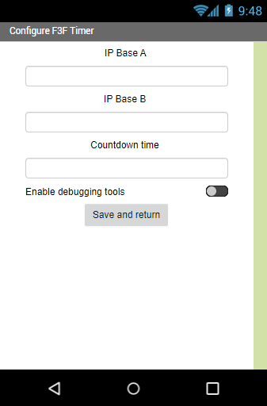

Enables menu containing manual triggers and the UDP listener

If you want to change the countdown time (time to gather altitude). Default: 30 seconds

Insert the IP address for Base A and Base B Raspberry Pi’s

## Main screen

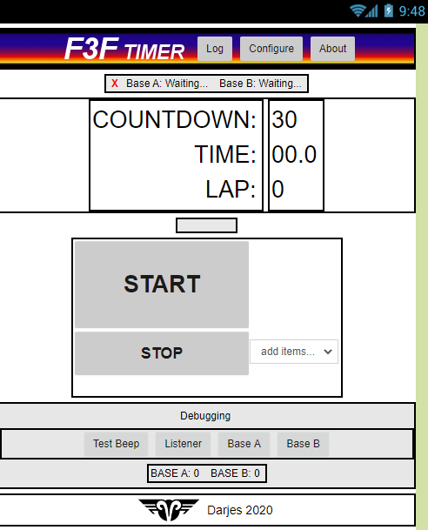

**Debugging tools**

Test speaker, manual trigger to simulate camera detection, open listener to view all UDP data and shows detections on both bases

Status bar shows the IP address of connected bases

**Timer interface**

Shows remaining countdown, total round time and current lap.

**Timer controls**

Start and stop the timer. Dropdown menu switches between continuous or single round mode (see below)

**Header menu**

**Log**: Opens log of recorded rounds

**Configure**: Opens configuration screen

**About**: Opens the about screen

## Log

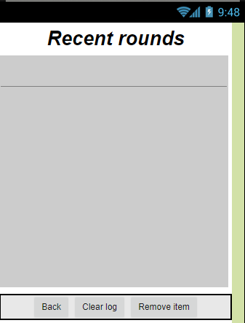

This screen lists the recorded rounds with date and time recording. Items can be removed individually (remove item) or all at once (clear log)

## Listener

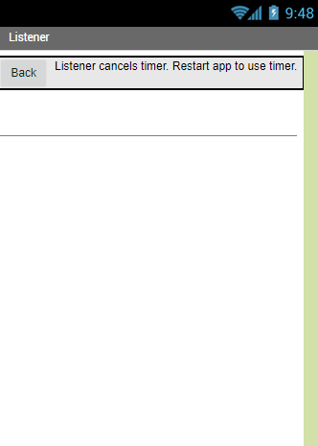

The listener is used to see what your cameras send out. If you are unsure if you have configured the IP address or other settings correctly you can use this screen to see the camera sends UDP packets what IP address the camera sends from.

**NOTE:** When this screen is opened the timer is no longer listening for UDP packets because the listener overrides the timer. Because of this it is required to close the app completely.

## Continuous / Single mode

When single mode is selected, the timer will stop when a round is finished. This means that the timer will have to be restarted manually using the START button. When continuous mode is selected, the timer will restart automatically and start a new countdown when the round is finished.

# Installing the app

To install the app, you will need an Android phone. The

# Using the timer

1. Connect the power on the router and the two piCAMTracker cameras with static IP addresses. Make sure the phone is connected to the same WiFi as the cameras.
2. Open the app.
3. Configure the IP addresses in app configuration to match the address of Base A and B.
4. Trigger both cameras (e.g. waving in front of them). The app will recognize the cameras and show a green checkmark at the status bar and text-to-speech will tell you that the timer is ready to start.
5. Choose between continues or single round mode.
6. Start the timer. This will give you a countdown in which you can gain altitude. The start button will be colored yellow during the countdown phase (default 30s). Text-to-speech will count down.
7. When the countdown is completed or when Base A is passed two times (exit and entry) the button will turn green and the main timer will start. Laps will be counted when the cameras are triggered.
8. Text-to-speech will tell you what lap you are on and when you are done the round time will be said. The round time is also stored in the log.
9. If continuous mode is selected the app will start the countdown phase again. If single mode is selected the timer will stop.

# Communication with piCAMTracker

## Triggers

piCAMTracker by barney-NG broadcasts different UDP messages over the network which are used as triggers for the app.

* The message «Event» is broadcasted when the tracking software detects a projectile.
* The message «UDPBeep Thread Start» is broadcasted when the tracking software is booted.

# Contact

If you have suggestions, questions, and other inquiries, please contact

[contact@darjes.no](mailto:contact@darjes.no)